**MANISHE SHETTY**

**202319028**

**M.sc AGRICULTURE ANALYTICS**



**ANALYZING PATTERN OF INDIAN REFUGEE AND IMMIGRATION TO CANADA**



## 

## 

## CONTENTS:

* ABSTRACT
* RESEARCH QUESTIONS
* ANALYSIS
* CONCLUSION
* REFERENCES

## 

## 

## 

## 

## ABSTRACT:

So far this year, Canada has accepted 1,344 refugee claims from India, making it the third-largest source country for refugees. It's behind Iran, with 2,730 accepted claims, and Turkey with 1,993, according to Immigration Refugee Board (IRB) data. According to an article by TOI, Canada aims to boost its immigrant intake by 500,000 in the year 2025. India seems to be the primary beneficiary in this decision. This was announced by Marc Miller who is the Minister of Immigration ,Refugees and Citizenship during the reveal of immigration plans for 2024-26. This information is beneficial for Indian Immigrants who look forward to relocating to Canada in hopes of a better future. To support the claims of the article regarding the tremendous increase in the immigration numbers throughout the years this report has been developed.

This Report makes an attempt answer the following questions:

1. What started the surge of migration and how has it increased throughout the years?
2. At present, do the problems which gave rise to this relocation still persist?
3. At which position does India stand with regards to immigration as compared with the Other countries?
4. What are the demographics of the Indian Population in canada?

During this informative analysis of the topic it was found that as years go by, more Indians would want to migrate to Canada in pursuit of a better career and a better life.

DATASETS AND ARTICLES USED:

Creating a project on the refugee crisis was a very informative journey. A plethora of datasets was needed for creating this project. Following are some key dataset along with their source.

1. Article:

The URL of the article on which this project is based is given, URLUSED:<https://timesofindia.indiatimes.com/india/canada-plans-to-admit-500000-immigrants-annually-by-2025-with-india-as-a-key-beneficiary/articleshow/104907856.cms?from=mdr.>

1. Immigrants from all the countries to canada dataset:

An attempt was made to compare the amount of refugees migrating from different parts of the world to Canada with the amount of refugees migrating from India and to visualize this information datasets from the United Nations High Commissioner for Refugees (UNHCR) was downloaded, which provides detailed dataset on refugees and migrants worldwide. The data set had seven columns named as Year,Country of origin,Country of origin (ISO),Country of asylum,Country of asylum (ISO),Refugees under UNHCR's mandate,Asylum-seekers. Out of these seven columns I used 2 columns that specified the country of origin and the number of asylum seekers.

URL Used:<https://www.unhcr.org/refugee-statistics/download/?url=yD7xH9>

1. Registered Indian population, area and region:

URL Used:<https://www.sac-isc.gc.ca/eng/1654268722711/1654268753990#tbc010>

<https://www.statista.com/statistics/538050/registered-indian-population-in-canada/>

Number of registered Indians in Canada, by region: This dataset had two columns, one column specifying the year of registered Indian population in Canada and the other column specifying the number of registered Indians in Canada

URL USED:<https://www.statista.com/statistics/538178/registered-indian-population-in-canada-by-region/>

1. Demographics of Canada

The socioeconomic conditions of Canada are crucial in analyzing the causes of immigration and the datasets for these were obtained from Wikipedia which provided an insightful dataset. The dataset had two columns, one specifying region and the other specifying the percent of people of that particular religion.

URL USED:<https://en.wikipedia.org/wiki/Indo-Canadians#:~:text=This%20report%20found%20that%20among,Evangelical%20%2B%209%25%20Catholic>).

1. Study permit holder information

This dataset contains the Country of Citizenship and columns specifying the total number of students who hold a study permit from 2015 to 2023.

URL USED: <https://open.canada.ca/data/en/dataset/90115b00-f9b8-49e8-afa3-b4cff8facaee>

## RESEARCH QUESTIONS:

The questions which have been posed earlier in this report will help us understand more thoroughly the reasons why the migration is increasing as time goes by. In the section below the reasons have been discussed and then visually presented.

* Till Sep 2023, Canada accepted 1344 refugee claims from India. Indian immigrants have also migrated at a large scale with numbers reaching as 485000 as of 2023. It’s one of the major countries which has accepted Indian refugees and migrants on such a large scale. In the last 20 years the amount of people who have seeked refuge from India in Canada has tremendously increased.
* In 2014, there were fewer than 20 percent refugee claims accepted but the number has increased strongly since then. While the reasons vary, the rate of acceptance has increased from 20 to 50 percent. This is mainly due to the fact that now Canada recognizes that there is human right violation in India leading to hostile situations for certain Indians in those hostile situations. In the past few years ,apart from the refugee situation, youngsters are also moving to Canada in an attempt to gain a better degree,better job and a better future as well.
* Canada’s population increase has been primarily due to Immigration and this increase has been a major reason for the country’s development in the past few years. This growth in population has also helped in balancing out the certain portions of the population such as the aged and retirees.

## ANALYSIS:

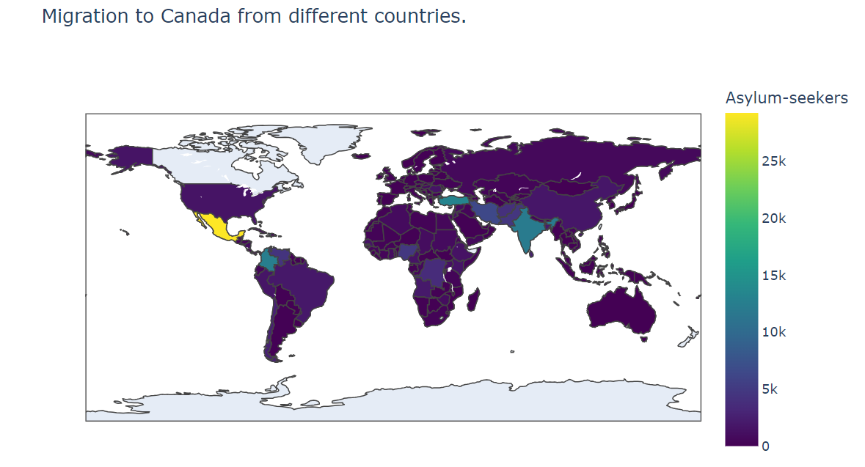

This above graph was developed using plotly.express from the library matplotlib. This figure was generated to visualize the number of immigrants from different parts of the world. When India is compared with other countries it may not be the place from where a majority of the immigrants come from but it still remains in the top 10.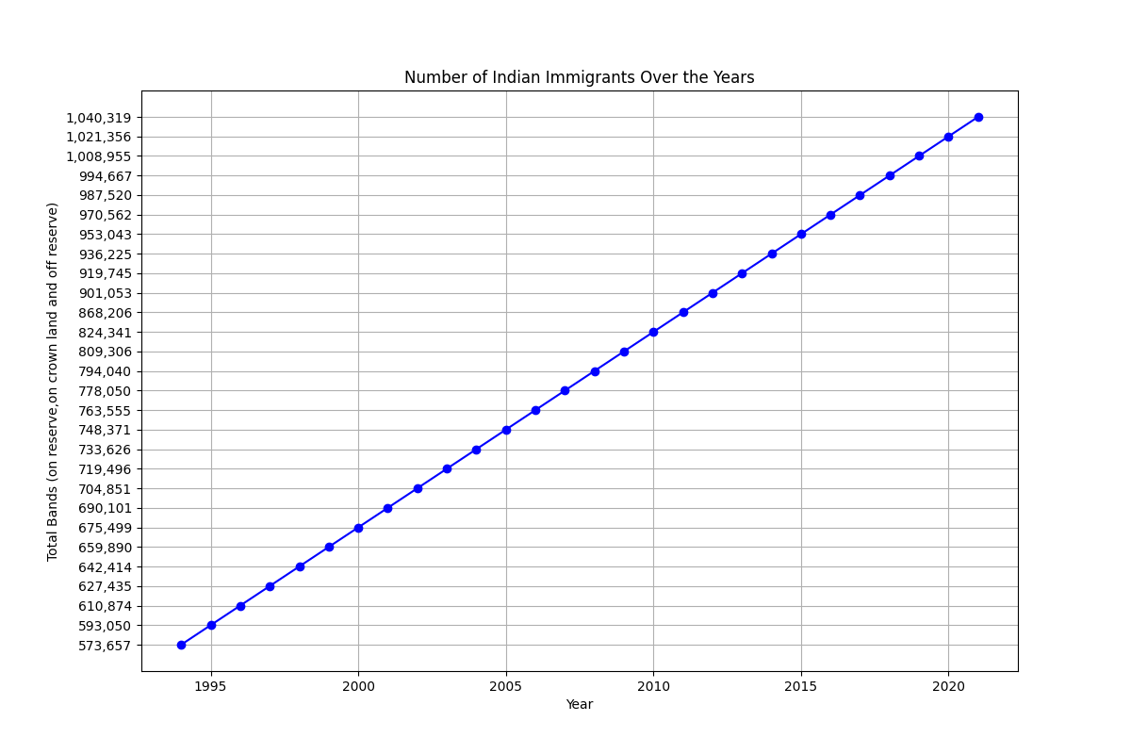This figure shows an increase in the number of Indian immigrants over the years along with their type of residence. This surge of people seeking shelter in Canada started in 1980 during the vicious fight between the Indian government and the sikh separatists.The Indian Government was against the establishment of sikh state which was to be called Khalistan. During the course of this fight, there was a lot of violence leading to high death numbers. Finally in 1993 the government declared an insurgency. This fight also led to an groundbreaking supreme court ruling in 1985 that led to the discovery of Immigration and Refugee boards. Even though the problem still persists, a majority of immigrants move to canada for a reason other than that.

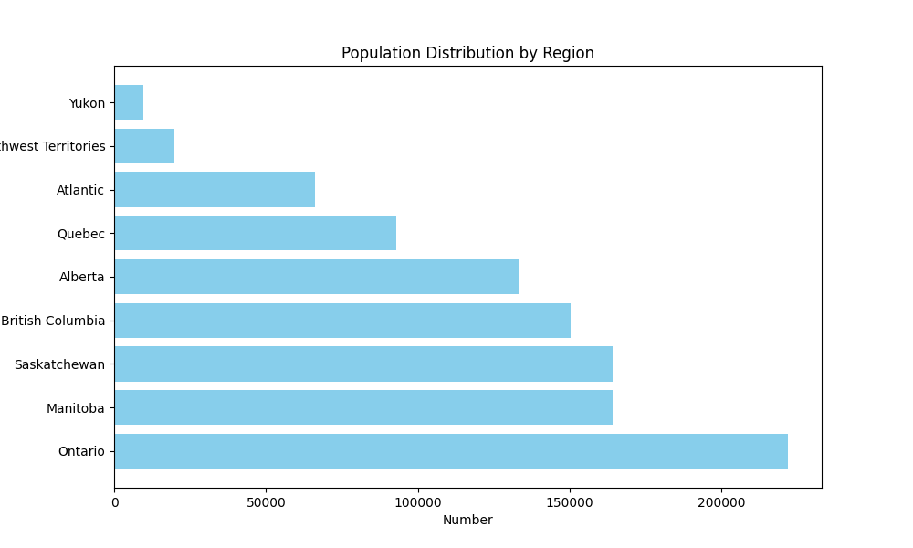

This graph gives an overview of the Population distribution of Indians in canada. Major population lies in ontario according to this graph because ontario is the center for economic activities. Hence majority of the Indian population migrating would want to stay in the economic hub for their own advancements.

Demographics of Indian population in canada:

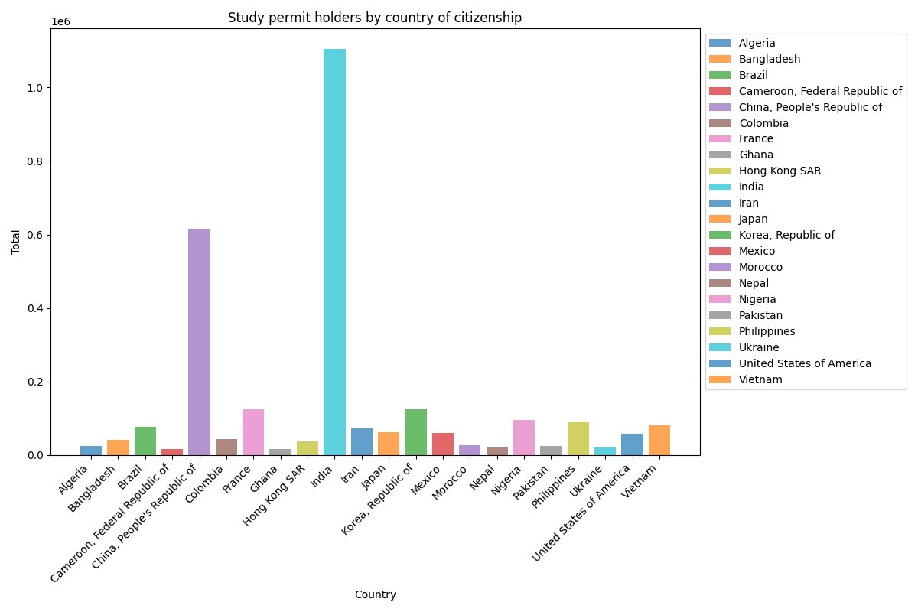

This graph gives one of the major reasons why Indians migrate to Canada other than for the reason of protection. Compared to other countries, the majority of the study permit holders are from India. Canada also remains to be one of the top choices of Indian students wanting to pursue higher education because of the quality of education as well as affordable tuition fee. Canada consists of the top 26 universities, which attracts a lot of students. On top of that, a student visa paves a path for permanent citizenship in canada.

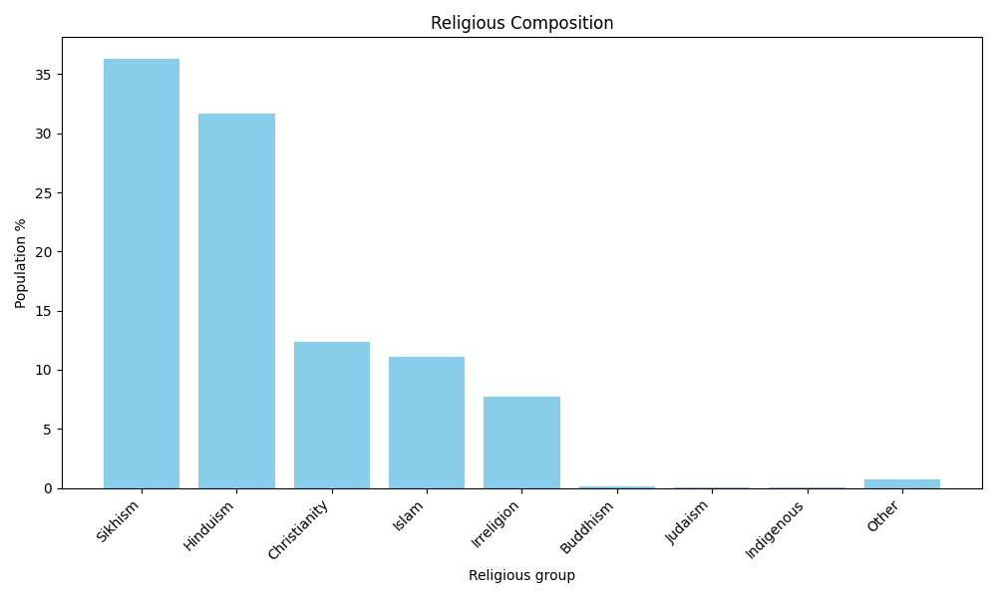

The above graph was created from a dataset downloaded from wikipedia. It shows that even though Canada is a christian country due to the increasing surge of migration religions such as sikhism and hinduism have dominated the country. This tells us how over the time Canada has boosted its migrant intake and diversified its population.

## 

## CONCLUSION:

This report is only limited to Canada and does not discuss the migration or refugee crisis of any other country. With more relevant demographic data which is historical this analysis could have answered a lot more questions which would arise on the cause of immigration and refugee crisis. The data was collected by the government of canada and for accuracy another dataset from a different website was also downloaded. There seemed to be not much gap in the findings of the data. The ambiguity and the authenticity of data seemed to be preserved with no overlapping or redundancy of the data.

## REFERENCES:

* <https://www.cbc.ca/news/canada/india-refugee-modi-1.6983416#:~:text=Canada%20accepted%203%2C469%20refugee%20claims,steadily%20in%20the%20last%20decade>.
* <https://en.wikipedia.org/wiki/Indo-Canadians#:~:text=This%20report%20found%20that%20among,Evangelical%20%2B%209%25%20Catholic>).
* <https://ucdp.uu.se/conflict/351>